

Course Title: Software Requirements Engineering
Course Code: SWE-231
Assignment
On
Requirement Analysis
Topic: Library Management System

Submitted to
Wadia Iqbal Chowdhury
Lecturer
Department of Software Engineering
Metropolitan University, Sylhet

Submitted by
Group:
Uzma Yakub
ID: 222-134-001
And
Tahmina Tanni
ID: 241-134-004
Batch: 6th
Department of Software Engineering
Metropolitan University,Sylhet

Date of Submission:11 April 2025

- Abstract
Requirement analysis stands as a pivotal phase in the software development life cycle,encompassing the identification, documentation, and comprehension of stakeholders' needs.
This SRS outlines the essential requirements to be considered during the development of a library management system. It outlines what the software should do, how it should behave, and what features it should include. It presents a comprehensive requirement analysis for the development of a library management system, encompassing software design,user interface, functional specialisation, and non-functional aspects.
It also includes use case diagrams to visualise user interactions and class diagrams to depict the system's structure.
In this SRS, we delve into the crucial process of requirement analysis as an integral part of developing a sophisticated library management system. We explore various methods, diagrams, and various aspects of requirement analysis that contribute to crafting a successful system that efficiently manages library resources while enhancing user experiences.

- Objective:
The LMS provides an enhanced user-friendly interface that automates the management of books, members, transactions, thereby increasing efficiency and reducing the workload of library staff.
The LMS consists of some essential features such as catalog management, user management and more.

- Introduction:
In an era of digital transformation, libraries are transitioning from traditional paper-based systems to digital platforms. A well-designed library management system is imperative for modern libraries to provide enhanced user experiences. It is a digital solution, designed to help the library admins efficiently manage their operations, resources, and services. It is a crucial tool that is designed to streamline and automate various tasks performed by the users and the librarian.

3.1. Purpose:
The LMS aims to provide a seamless experience for intended audience- users, librarian and admin. It aims to provide the user with the ability to borrow and return books and to create accounts and sign in to their account using different methods. It offers a user-friendly interface for users to discover books across genres, place orders, buy books, cancel orders, manage their accounts and interact with the cover page of the book containing author information.

3.2. Scope:
The LMS is designed to streamline the process of managing books, orders, and a library's book inventory. The users can reserve books and librarian will have administrative privileges, enabling them to oversee tasks such as cataloguing books, managing loans, and efficiently handling user accounts.
The LMS will support role-based authentication, ensuring that users can only access the features relevant to their assigned roles. Users cannot sign in using the librarian role, and neither librarians nor users can access the system using the admin role. Each user type has a unique username for authentication.

3.3. Definitions and Acronyms:
3.3.1. LMS: Library Management System
3.3.2. User: A registered library member
3.3.3. Librarian: A staff member managing library operations
3.3.4. Admin: A system administrator

3.4. References:
https://creately.com : created diagrams using creately.
“Activity diagram”. Smart draw. https://www.smartdraw.com/activity-diagram/#:~:text=An%20activity%20diagram%20visually%20presents,can%20be%20sequential%20and%20concurrent.
Arms, William Y. “Digital Libraries”. Cornell University. https://www.cs.cornell.edu/wya/DigLib/text/Chapter8.html
Chuan, Tan Chaur. “Library Management System Project Report”. https://studylib.net/doc/26303523/library-management-system-i-library-mana
Fatima, Mehek. Library Management System. Scribd. https://www.scribd.com/document/121547853/library-management-system
“Integrated Library System-an overview”. Science Direct. https://www.sciencedirect.com/topics/computer-science/integrated-library-system#:~:text=An%20Integrated%20Library%20System%20(ILS,to%20facilitate%20library%20operations%20efficiently.
“Library Management System”. Scribd. https://www.scribd.com/document/121547853/library-management-system
Musale, Prashant. “What is a Library Management System?” Egenius. July 5, 2024. http://egenius.in/blogs/what-is-a-library-management-system/
NishanMainali56. SRE Project Library Management System. Scribd. https://www.scribd.com/document/690467783/SE-Project-Library-Management-System
Rashid, Md Harun R. “Hardware and Software Requirements for Libary Automation and Digitization”. Limbd. https://limbd.org/hardware-and-software-requirements-for-library-automation-and-digitalization/
Singh, Priyanka. “Library Management System”. Research Gate. June 2024, https://www.researchgate.net/publication/381656933_LIBRARY_MANAGEMENT_SYSTEM
“Software Requirement & Specification Document for Library Management System”. Slide Share. Dec 15 2023. https://www.slideshare.net/slideshow/software-requirement-specification-document-for-library-management-system/264651982
“UML Sequence Diagram Tutorial”. Ludichart.https://www.lucidchart.com/pages/uml-sequence-diagram#:~:text=A%20sequence%20diagram%20is%20a,to%20document%20an%20existing%20process.

3.5. Overview:
The SRS contains-
- Details on various types of factors affecting the LMS product and its requirements such as, the function of LMS, its constraints and more.
- Specific Requirements of LMS such as functional and nonfunctional requirements, software design requirements and attributes that serve as requirements.
- Details on which SDLC Model is suitable for the LMS.

- Overall Description:
There are some general factors that affect the LMS product and its requirements. Those are as follows:
- Product perspective
- Product functions
- User characteristics
- Constraints
- Assumptions and dependencies
- Apportioning of requirements.
4.1. Product perspective:
The LMS is a mobile application designed for both online and offline library access. The LMS depends on the following constraints to operate:
- System interfaces
- User interfaces
- Hardware interfaces
- Software interfaces
- Communications interfaces
- Memory
- Operations
- Site adaptation requirements
4.1.1. System interfaces:
The primary system interfaces commonly found in an LMS are:
1. Cataloging:
- Online Public Access Catalog (OPAC):
Allows users to search for books and other library materials by title, author, subject, etc.
- Cataloging Interface:
Enables librarians to create and edit catalog records, including adding details like title, author, ISBN, subject headings, and keywords.
- Authority Control:
Helps maintain consistency in cataloging data by controlling the terms used for authors, subjects, and other entities.
2. Circulation:
- Check-in/Check-out: Allows librarians to record when books are borrowed and returned.
- Patron Management: Enables librarians to manage patron accounts, including registration, renewals, and fines.
- Reservation System: Allows users to reserve books that are currently checked out.
3. Acquisitions:
- Order Management: Enables librarians to place orders for new books and other library materials.
- Vendor Management: Allows librarians to manage relationships with vendors and track payments.
- Receiving and Processing: Enables librarians to record the receipt of new materials and prepare them for circulation.
4. Reporting:
- Circulation Statistics: Provides data on book circulation, including the most borrowed books and patron borrowing patterns.
- Inventory Reports: Allows librarians to track the status of library materials, including which books are currently available and which are overdue.
- Financial Reports: Provides data on library spending, including acquisitions costs and fines collected.
These modules collectively enhance the efficiency of library operations, improve user experience, and ensure effective resource management.

4.1.2. User interfaces:
Common user interfaces in an LMS include:
- Librarian Interface: managing catalog, circulation, user account, report and analysis, inventory,serials and user inquiries.
- User Interface: access to online public catalog,digital resources such as e-books, audiobooks, or online journals, account management, self-checkout using barcode, contacting the library staff and providing feedback on the library services.
- Admin Interface: configure system settings, manage user roles and permissions, generate reports, and oversee overall system performance.
- Mobile Interface: provides mobile-friendly interfaces or dedicated apps, enabling users, librarian and admin to access library services from smartphones and tablets.
These interfaces work together to provide a seamless and efficient experience for all users interacting with the library system.
A list of do’s and don'ts on how the LMS will appear to the users, librarian and admin:
User Interface:
Do's:
- Ensure the interface is user-friendly, allowing patrons to effortlessly search, borrow, and return books.​
- Implement search filters by title, author, genre, and publication date to enhance the user experience.​
- Display up-to-date information on book availability to prevent user frustration.​
- Track borrowed books, due dates, and any outstanding fines.​
- Optimize the interface for various devices, including desktops, tablets, and smartphones, ensuring accessibility.
Don’ts:
- Do not let users sign in to their account using librarian or admin role selection.
- Do not leave users uncertain about the feedback they sent.
- Do not design an interface with too much information, which can confuse the users.
Librarian Interface:
Do’s:
- Enable librarians to easily add, update, or remove book records, including details like ISBN, title, author, and genre.​
- Provide functionalities to manage user registrations, monitor borrowing history and enforce library policies.
- Facilitate the management of book reservations and waiting lists to ensure fair access to resources.
- Implement alerts for overdue books, reservation availability, and other pertinent information to keep users informed.
Don’ts:
- Do not design interfaces that are difficult to navigate or require extensive training to use effectively.​
- Do not let the librarian to sign in to their account using admin role selection.
Admin Interface:
Do’s:
- Provide an overview of library operations, including user statistics, book inventories, and system performance metrics.​
- Allow admin to define and manage roles and permissions for staff and users to maintain security.
- Enable customization of system settings to align with the library's specific policies and procedures.
- Implement features to track system usage, generate reports, and monitor compliance with library regulations.​
Don’ts:
- Avoid creating an interface that is too complex, hindering the admin’s ability to manage the system efficiently.
- Do not neglect the implementation of detailed logs for the actions of users and the librarian recorded within the system, which are crucial for auditing and troubleshooting.

4.1.3. Hardware interfaces:
Server Side:
- Operating System: Windows 9x/xp ,Windows ME. Ensures LMS can operate on a variety of operating System
- Processor: Pentium 3.0 GHz or higher. Handles the server's computational tasks efficiently, including data processing and user request management.​
- RAM: 256 Mb or more. Ensures smooth operation of the LMS, supporting multiple simultaneous users.
- Hard Drive: 10 GB or more. Accommodates the LMS software, databases, logs, and other essential data, providing sufficient space for current and future needs.​
Client side:
- Operating System: Windows 9x or above, MAC or UNIX. Allows intended audience with diverse operating systems to access the LMS seamlessly.​
- Processor: Pentium Ill or 2.0 GHz or higher. Ensures responsive interaction with the LMS, including quick load times and efficient data processing.​
- RAM: 256 Mb or more. Ensures the LMS interface operates smoothly, especially when accessing large datasets or performing multiple tasks simultaneously.​
The LMS will support the following devices:
- Desktops and Laptops: Compatible with modern web browsers (e.g., Chrome, Firefox, Safari) of Windows(9x or above), macOS, and Linux operating systems.
- Tablets and Smartphones: Compatible with iOS and Android platforms.
Logical Characteristics of Hardware Interfaces:
- Client- Server Architecture: Client devices communicate with the server to access library resources. Allows centralized data management and consistent user experiences across devices.​
- Responsive Design: Interface adjusts to different screen sizes and orientations, ensuring optimal performance cross various devices, from desktop monitors to mobile screens.​
- Platform-Specific Adaptations: Provide adaptations such as optimized interface or functionality, tailored to specific operating systems (Windows, macOS, iOS, Android) to enhance performance and user experience.
- Data Synchronization: Client devices will synchronize data with the server to ensure that users have access to the most current information, regardless of the device used.
- Network Equipment: Sufficient bandwidth (routers, switches) and network security measures (firewall) is necessary to support simultaneous users and protect their data.
- Peripheral Devices: The LMS supports barcode scanners, RFID readers, printers and scanners to support library functions.

4.1.4. Software interfaces:
4.1.4.1 The LMS will interact with various software components, including:
4.1.4.1.1 Operating Systems:
Name: Microsoft Windows
- Mnemonic: Windows
- Specification Number: N/A
- Version Number: Windows 9x, Windows XP, Windows ME
- Source: Microsoft Corporation
Name: Apple macOS​
- Mnemonic: macOS
- Specification Number: N/A
- Version Number: macOS 10.0 and above
- Source: Apple Inc.
Name: Linux​
- Mnemonic: Linux
- Specification Number: N/A
- Version Number: Kernel 2.6 and above
- Source: Various distributions
Name: Apple iOS​
- Mnemonic: iOS
- Specification Number: N/A
- Version Number: iOS 9.0 and above
- Source: Apple Inc.
Name: Google Android​
- Mnemonic: Android
- Specification Number: N/A
- Version Number: Android 5.0 (Lollipop) and above
- Source: Google LLC
4.1.4.1.2 Application Development Framework:
Name: Active Server Pages​
- Mnemonic: ASP
- Specification Number: N/A
- Version Number: 3.0
- Source: Microsoft Corporation
4.1.4.1.3 Database Management Systems:
Name: Microsoft SQL Server​
- Mnemonic: SQL Server
- Specification Number: N/A
- Version Number: 2008 and above
- Source: Microsoft Corporation
Alternative:
Name: MySQL
- Mnemonic: MySQL
- Specification Number: N/A
- Version Number: 5.7 and above
- Source: Oracle Corporation
Name: PostgreSQL
- Mnemonic: PostgreSQL
- Specification Number: N/A
- Version Number: 9.6 and above
- Source: PostgreSQL Global Development Group
4.1.4.1.4 Web Servers:
Name: Internet Information Services​
- Mnemonic: IIS
- Specification Number: N/A
- Version Number: 5.0 and above
- Source: Microsoft Corporation
Alternative:
Name: Apache HTTP Server
- Mnemonic: Apache
- Specification Number: N/A
- Version Number: 2.4 and above
- Source: Apache Software Foundation
Name: Nginx
- Mnemonic: Nginx
- Specification Number: N/A
- Version Number: 1.10 and above
- Source: Nginx, Inc
4.1.4.2 Interface with other application systems:
Accounts Receivable System: The LMS will generate transaction records regarding the user fines or fees associated with overdue or lost library materials.
General Ledger System: Ensures financial reporting by recording financial transactions related to library operations, including acquisitions and user fees.​
User Information System: Synchronize registered users’ data so that only registered users have borrowing privileges. The LMS will periodically import user data from the SIS via RESTful API, updating user profiles and access rights accordingly.​
User Authentication Interface:Ensures secure access to the LMS by verifying user credentials where users submit credentials through an HTML form securely using HTTPS.
Database Management System: Stores, retrieves, and manages data related to books, users, transactions, and other library operations. The LMS employs SQL (Structured Query Language) to interact with the DBMS. Standard SQL commands such as SELECT, INSERT, UPDATE, and DELETE are used to perform library operations.
Web Server Interface: The LMS operates over the HTTP/HTTPS protocols.
Self-Service kiosks Interface: Allows users to check out and return books independently through integration with self-service kiosks.
Online Public Access Catalog (OPAC) Interface:Online Public Access Catalog (OPAC) Interface.

4.1.5. Communications interfaces:
The various interfaces to communications are::
4.1.5.1 Network Connectivity:
- Internet Access
- Broadband Internet
4.1.5.2 Local Network Connections
- Ethernet
- Wi-Fi
4.1.5.3 Communication Protocols
- Application- Level Protocols
- Library- Specific Protocols
4.1.5.4 External System Interfaces
- Email Communication
- Data Synchronization and Exchange

4.1.6. Memory:

The applicable characteristics and limits on primary and secondary memory are:
- Primary Memory: Minimum of 4 GB RAM for client devices.
- Secondary Memory: Adequate storage for database and application files, depending on the library's size and user base.

4.1.7. Operations:
Data Processing Support Functions in a LMS-
4.1.7.1 Intended Audience Operations:
The LMS will support multiple operational functionalities to ensure smooth interactions between users, librarians, and administrators. The operations include-
User Operations:
- Registering and logging into the system using email and password.
- Searching for books using filters (title, author, genre, publication year, etc.).
- Borrowing books (physical or digital copies).
- Returning books within the due date.
- Viewing borrowed book history and due dates.
- Purchasing books if available for sale.
- Cancelling an order before processing.
- Writing and viewing book reviews.
Librarian Operations:
- Adding, updating, and deleting books from the catalog.
- Organizing books alphabetically based on category,title or author name.
- Maintaining Online Public Access Catalog.
- Managing purchase orders and invoice processing.
- Tracking the status of items being acquired (ordered, received,invoiced).
- Managing book inventory (available, borrowed, overdue, etc.).
- Approving and tracking book returns.
- Managing reservations and renewals.
- Sending notifications for due dates and overdue books.
- Calculating fines and penalties
- Generating reports on book usage and circulation.
Admin Operations:
- Managing user roles (assigning librarian/admin privileges).
- Configuring system settings.
- Monitoring system performance and usage statistics.
- Handling security settings (user authentication and data protection).
4.1.7.2 Other Operations:
System Operations:
- Providing a user-friendly interface for the librarian and patrons to interact with the system efficiently.
- Automatically backup the library’s data regularly to ensure data is protected in case of system failure.
- Automatically checks the system health, data integrity and security and updates the software, database and configuration to ensure optimal performance and enhanced security.
- Generating the fine slip according to the returned date when book is returned by the member
- Generating reports on library usage

4.1.8. Site adaptation requirements:
The LMS will be adaptable to different library setups, including:
- Public libraries, where users borrow books for free with a membership.
- University libraries, with restricted access based on student/faculty status.
- Private libraries, offering subscription-based access or paid book rentals.
4.2. Product functions:
The core functionalities of the LMS include:User Authentication & Role Management, Book Catalog Management, Borrowing & Returning Books, Book Search & Discovery, Order (purchase) Management, User Interaction & Reviews, Notifications & Alerts and Reports & Analytics.

4.3. User characteristics:
The system will serve multiple user roles:
- General Users (Students, Readers, Researchers)
  - Basic computer knowledge.
  - Ability to search for books and manage borrowed items.
- Librarians
  - Familiarity with book management systems.
  - Trained to handle book lending, returns, and inventory
- Admins:
- Advanced technical knowledge.
- Responsible for system maintenance and security.

4.4 Constraints:
The items that will limit the developer’s options are given below
a)Regulatory policies
b) Hardware limitations (e.g., signal timing requirements)
c) Interfaces to other applications
d) Parallel operation
e) Audit functions
f) Control functions
g) Higher-order language requirements
h) Signal handshake protocols (e.g., XON-XOFF, ACK-NACK)
i) Reliability requirements
j) Criticality of the application
k) Safety and security considerations:
4.5. Assumptions and dependencies:
The LMS assumes:
- Users have access to stable internet connections for online features.
- Library staff are responsible for book inventory updates.
- The system relies on a relational database for storing user and book data.
Dependencies:
- The LMS depends on third-party authentication services (Google, email login).
- Payment processing depends on external payment gateway providers.
4.6. Apportioning of requirements:
Some features will be developed in future phases:
- AI-based book recommendations.
- Integration with third-party eBook services.
- Automated chat support for library inquiries.
5. SDLC Model:
The LMS was designed using the Waterfall Model so that users can proceed to next steps, if and only if the current step is completed. But the LMS follows the Agile Model so that any future changes could be made to the system since Agile development allows incremental updates and continuous user feedback. Libraries have evolving needs, requiring flexibility in feature updates.

6. Specific Requirements:
Listing all of the software requirements for LMS to a level of detail sufficient to enable designers to design such a LMS that satisfies those requirements, and testers to test that the LMS satisfies those requirements:
6.1. External Interface:
Give a detailed description of all inputs into and outputs from the LMS.

Input Interfaces:
- User Login: Accepts email and password for authentication.
- Book Search: Accepts keywords and filter selections.
- Borrow Request: Accepts user input for borrowing requests.
- Return Request: Accepts user confirmation for returning books.
- Payment System: Accepts payment details for book purchases.

Output Interfaces:
- Search Results: Displays book availability.
- Borrowing Status: Shows due dates and return deadlines.
- Notification System: Alerts users of due dates and overdue books.
- Payment Confirmation: Displays successful or failed transactions.
6.2. Functional Requirements of LMS:
Functional requirements should define the fundamental actions that must take place in the software in accepting and processing the inputs and in processing and generating the outputs. The functional requirements encompass a range of functionalities, including book registration, user authentication, book borrowing and returning, as well as efficient book search mechanisms.
The Functional Requirements are listed below:
User Registration and Authentication:
Users can create accounts using Google account, phone number, or email address.
Account creation should require essential details like name, contact, and password
Store user information such as name, contact details, and library ID.
Users can sign in using their registered credentials.
Upon registration, users receive a code via email,call or SMS for account verification.
User Roles:
Upon launching the app, the intended audience sees:
"Are you a… ?"
- User
- Librarian
- Admin
which means, intended audience are prompted to select their user role.

Cover Page and Genre Display:
Display a list of available book genres.
Users can browse Books.
Allow users to click on genres to view books and cover pages of books. Cover page should contain the author's name.
Catalogue Management:
Librarians should be able to add, edit, and delete books from the catalogue. Librarians can mark books as checked in or checked out through the system.
Users can browse books.
Users should be able to search for books by title, author, or category. Patrons can check out books using their library accounts or Library cards, and the system will update the book's status accordingly.
Patrons can return books, and the system will update the book's availability status. Availability status of books should be displayed.
Borrowing and Returning Books:
Users should be able to borrow books.
Users should be able to return books.
The system should enforce due dates and generate overdue notifications.
Orders
Users can place orders for books.
Users can buy books.
Users can cancel orders.
Book Purchase:
Payment gateway integration for secure transactions
Librarian Management:
Librarians can access a separate dashboard for inventory, loans, reports and book management.
For patrons: Searching for books, checking availability, placing holds, renewing loans
Librarians can generate various reports, including:
- Book circulation report: Shows the number of check-outs and returns for each book.
- Overdue books report: Lists books that are overdue and the associated patrons.
- Popular genres report: Displays the most borrowed genres in a given timeframe.

Reservation System:
Users should be able to reserve books that are currently borrowed.
Reserved books should be held for a specified period before being made available to others.
Patrons can place holds on books that are currently checked out by others.
The system will manage a hold queue, ensuring that holds are fulfilled in the order they were placed.
Librarians can mark holds as fulfilled when a book becomes available.
Patrons can place holds on unavailable books, and librarians can manage hold queues.

User Profile Management:
Users should be able to view their borrowing history and account details.
Users should be able to update their account details including contact information.
Users should be able to sign out.
Librarians can view and user account information, including contact details and borrowing history.

Notifications:
Users should receive notifications for due dates, overdue books, and reservation availability.
The system will send automated notifications to patrons for due dates, hold availability, and overdue fines.
Notifications can be sent via email or SMS based on user preferences.

Admin Functions:
Admins should be able to manage user accounts and privileges.
Admins should be able to generate reports on book circulation, popular titles, etc.
Functional Requirement Specialisation
Functional requirements describe the specific functionalities the system must support:
- Class diagrams: aid in representing the methods like 'borrowBook()' and 'returnBook()' within the 'User' class.

6.3. Non functional Requirements.
6.3.1 Performance Requirements:
- The LMS shall support 1000+ concurrent users.
- Search queries should return results within 2 seconds.
- 95% of transactions should be completed in under 1 second
- The system should handle concurrent user requests efficiently, ensuring minimal response time even during peak usage.
- Minimal system downtime:Book searches and transactions should have minimal response times.
- Quick loading of book genres and cover pages.

6.3.2 Logical Database Requirements:
Logical requirements for any information that is to be placed into a database are specified below:
- The database shall store user details, book records, and transaction history.
- Each book entry shall include ISBN, title, author, genre, availability, and publication date.
- User borrowing history shall be stored for future references.
- All transactions shall be logged with timestamps.

6.3.3 Design Constraints:
The design constraints that can be imposed by other standards, hardware limitations, etc are specified below:
- The system shall be compatible with web and mobile platforms.
- The database shall support SQL-based queries for scalability.
- The UI shall follow accessibility guidelines for visually impaired users.

6.3.4 Standards Compliance:
The requirements derived from existing standards or regulations are specified below:
- The LMS shall comply with ISO 27001 security standards.
- Data logs shall follow GDPR compliance for user privacy.
- Reports shall adhere to Dublin Core Metadata Standards for cataloging.

6.3.5 Software System Attributes:
There are a number of attributes of LMS that can serve as requirements. It is important that required attributes be specified so that their achievement can be objectively verified. Subclauses 6.3.5.1 through 6.3.5.13 provide a partial list of examples.

6.3.5.1 Reliability:
The factors required to establish the required reliability of the LMS at time of delivery are specified below:
- The system should maintain accurate records of book availability and user interactions.
- Backup and recovery mechanisms should be in place to prevent data loss.
- The system should maintain 99.9% uptime.
- Critical functions like borrowing and searching should be fail-safe.

6.3.5.2 Availability:
The factors required to guarantee a defined availability level for the entire LMS such as checkpoint, recovery, and restart are specified below:
- The system should be available for use during library operating hours.
- Scheduled maintenance and downtime should be communicated in advance.
- The system should be available 24/7, except for scheduled maintenance.
- Automatic backups should be taken every 24 hours.

6.3.5.3 Security:
The factors that protect the LMS from accidental or malicious access, use, modification, destruction, or disclosure are specified below -
- User authentication and authorization mechanisms should be robust.Protection against unauthorised access to sensitive user data.
- User passwords and sensitive data should be securely stored and transmitted.
- Secure connection for online transactions.
- All passwords shall be stored using encryption.
- Multi-factor authentication should be available for admin accounts.
- User activities should be logged for security audits.

6.3.5.4 Maintainability:
The attributes of LMS that relate to the ease of maintenance of the LMS itself are specified below:
The system should allow modular updates without disrupting functionality.
Bug reports should be handled through an issue tracking system.

6.3.5.5 Scalability:
- The system should be able to accommodate(handle) an increasing number of users, books, and transactions
- The software architecture should support the library's growth in terms of book collection and user base.
6.3.5.6 Compatibility:
- The system should be compatible with different devices and browsers.
6.3.5.7 Data Integrity:
- Data entered into the system should be accurate and consistent.
- It should integrate with barcode scanners, online catalogues, and other library systems if needed.
- Changes to data should be logged and auditable.
- The system should integrate with barcode scanners and RFID technology for efficient book management.
- Integration with online book catalogues and external APIs for book data enrichment should be considered.
6.3.5.8. Constraints and Assumptions
The system assumes that the library has existing book data that can be imported into the software.
It assumes that the library's network infrastructure supports the required communication for notifications.
6.3.5.9 Dependencies:
The LMS will interact with external systems like databases and APIs
6.3.5.10 Reviewing and Validating:
Reviewing the requirements document to ensure accuracy and alignment with expectations.
6.3.5.11 Documentation:
Compiling the requirements into a formal document that serves as a reference for the development team.
6.3.5.12 Iterating:
As development progresses, taking preparation for revisiting and updating requirements based on any new insights or changes.
6.3.5.13 Portability:
The attributes of LMS that relate to the ease of porting the LMS to other host machines and/or operating systems are specified below:
- The LMS shall be compatible with Windows, macOS, Android, and iOS.
- The application should be deployable on cloud-based platforms.

6.4 Software Design Requirements:
Software design requirements outline the overarching structure and technological foundation of the system. They encompass decisions on programming languages, frameworks, databases, and provide guidance on the overall architectural blueprint of the system.
The software design requirements pertain to the overall structure and components of the library management system.
7. Diagrams
7.1 Class Diagrams:
Purpose of Class diagrams: Class diagrams provide a structural view of the system's architecture It provides an overview of the system's class structure. It depicts the relationships between classes(objects),their attributes and methods within the system. They aid in designing the software's structure, including the objects that interact and collaborate to achieve the desired functionalities.
In the context of a Library Management System, class diagrams represent classes like Users, Books, Orders, Genre, and Librarians(Library staff), showcasing their attributes and associations, highlighting the system's architecture and data flow. It aids in visualising the relationships between different components, such as 'Book,' 'User,' and 'Library Staff.'
Class diagrams play a pivotal role in shaping the software's underlying structure, outlining the entities and their interactions that facilitate the system's functionality.

User
- userID : int
- name : String
- contact : String
- libraryID : int
+ signIn() : void
+ signOut() : void
+ borrowBook(bookID : int) : void
+ returnBook(bookID : int) : void
+ placeOrder(bookID : int) : void
+ cancelOrder(orderID : int) : void
+ viewBorrowingHistory() : BorrowingHistory[]
+ updateAccountDetails() : void
+ setName(name : String) : void
+ setContact(contact : String) : void
+ setLibraryID(libraryID : int) : void
↓ ⬇️
↓ ⬇️
BorrowedBook
-bookID
- userID
- borrowDate
- returnDate : Date
+ getUserID()
+getBorrowDate()
+getReturnDate()
+setBookID(bookID)
+setUserID(userID)
+getBorrowDate(borrowDate)
+setReturnDate(returnDate)
⬇️
↙️⬅️
Notification
- notificationID : int
- userID : int
- message : String
- timestamp : Date
+ getNotificationID()
+ getUserID()
+ getMessage()
+ getTimestamp()
+setNotificationID(notificationID)
+ setUserID(userID)
+setMessage(message)
+setTimestamp(timestamp)

⬇️
Librarian
- staffID : int
- name : String
- contact : String
+ addBook(bookDetails : Book) : void
+ editBook(bookID : int, newDetails : Book) : void
+ deleteBook(bookID : int) : void
+ markBookAsCheckedOut(bookID : int) : void
+ markBookAsCheckedIn(bookID : int) : void
+ generateReports() : Report
+ setName(name : String) : void
+ setContact(contact : String) : void

↓

Book
-bookID : int
- title : String
- author : String
- genre : String
- availability : boolean
+ getDetails() : String
+ checkAvailability() : boolean
+ updateAvailability(status : boolean) : void
+ setTitle(title : String) : void
+ setAuthor(author : String) : void
+ setGenre(genre : String) : void
+ setAvailability(availability : boolean) : void

⬇️ ⬆️
⬇️
Genre
- genreID
- name
⬇️
↙️⬅️
Order
- orderID
- bookID
- userID
- status
+ getStatus()
+ cancelOrder()
⬇️ ⬇️
BookPurchase
-paymentGateway
+initiatePayment()
+processPayment() +confirmPayment()
⬇️
BorrowedBook
-bookID: int
- userID: int
- borrowDate
- returnDate : Date
+ getUserID() : int
+ getBorrowDate() : Date
+ getReturnDate() : Date
+ setBookID(bookID : int) : void
+ setUserID(userID : int) : void
+ setBorrowDate(borrowDate : Date) : void
+ setReturnDate(returnDate : Date) : void

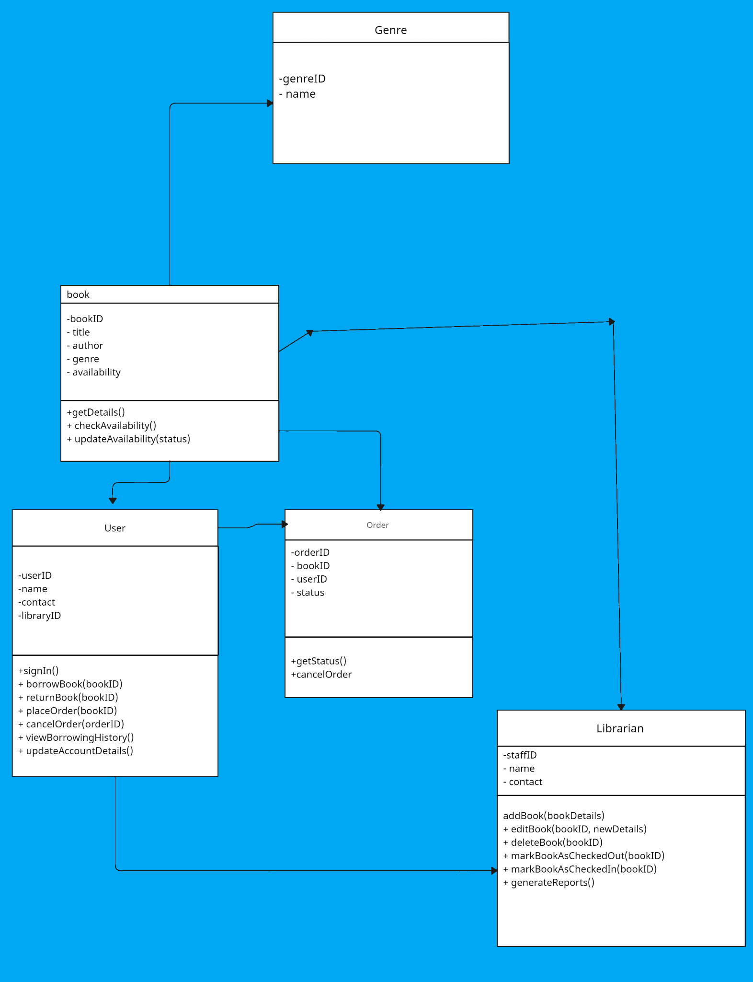

Fig: Class diagrams

7.2 Activity Diagram:
An activity diagram visually presents a series of actions or flow of control in a system similar to a flowchart or a data flow diagram. Activity diagrams are often used in business process modeling. They can also describe the steps in a use case diagram. Activities modeled can be sequential and concurrent.

7.3. Sequential Diagram:
A sequence diagram is a type of interaction diagram because it describes how—and in what order—a group of objects works together. These diagrams are used by software developers and business professionals to understand requirements for a new system or to document an existing process.
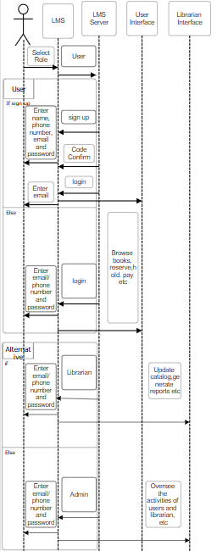

7.4Use Case Diagrams:
Purpose of use case diagrams:
Use case diagrams depict the functional aspects of the software and help in identifying the system's major functionalities and user roles. It serves as a compass, guiding the software development process by highlighting core functionalities and aiding in the identification of user roles. It facilitates an overall understanding of the system's behaviour
In the Library Management System, use case diagrams visually depicts (represents) how librarians and different users interact dynamically with the system's features to achieve specific goals, such as 'Librarian Adding a Book', 'User Searching for a Book', user registration, book browsing and order placement

User | System | Librarian
Manage profile Borrow book
Return book
Search book
Pay fine
Manage books
Generate report

User
Borrow book
|
Return book
|
Search and browse book
|
Pay fine

⬇️

Librarian
Manage books
|
Generate report

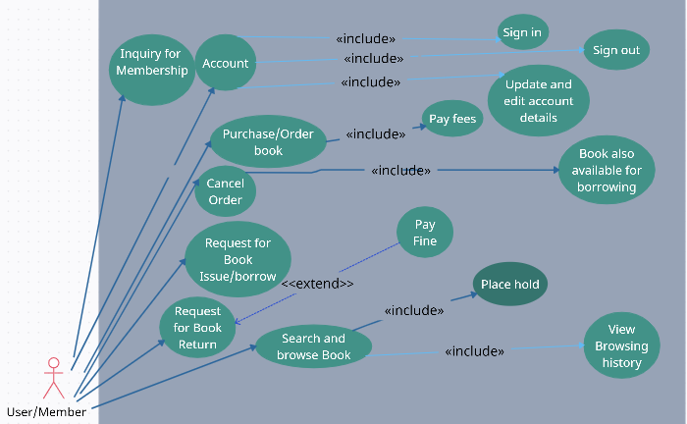

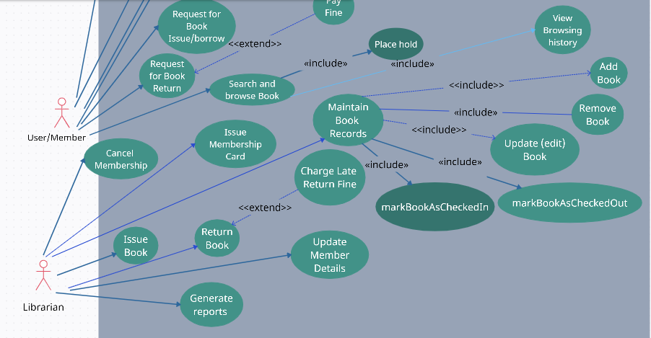

Fig: Use case diagram

Use case diagrams and class diagrams are essential tools for designing and communicating the functionality and structure of a complex system like a Library Management System. They ensure clarity, proper organisation, and effective implementation of the software. The incorporation of class diagrams and use case diagrams helps in visualising the system's structure and user interactions, contributing to a successful development process.

8. Conclusion
In conclusion, requirement analysis stands as a cornerstone of software development, acting as the bridge between stakeholders' needs and the tangible software system. It ensures that stakeholder needs are accurately captured and translated into a functional system.
The requirement analysis for the library management system highlights the essential aspects to consider during its development. The software design, UI, functional specialisation, and non-functional requirements collectively ensure a well-rounded and effective system that addresses the needs of both library staff and users.
By adopting a systematic and structured approach and creating crucial diagrams such as use case diagrams and class diagrams, we can effectively design a comprehensive library management system that aligns with stakeholder expectations, elevates library operations, and enhances the overall user experience.

